How to go from raw Fluidigm data to usable genepop files.

1. Put your fluidigm raw data into a working directory
2. Put a copy of this R code in that working directory: 
3. Open R code
   1. Set working directory
   2. Set file name for import function
   3. Make sure the two “write” functions are not in comment mode
   4. Run from lines 1 through 38
4. Open exports. They will be “new_test.gen” and “SnpKey.csv”
5. “new_test.gen” will look like this



Put a hard return at the top (blank line)

1. Copy the numbered column from the SNP key file

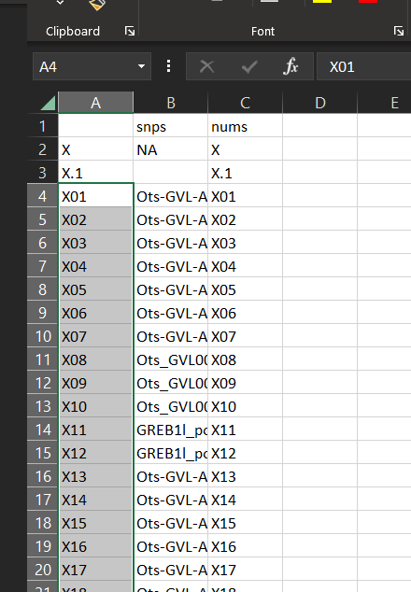

1. Go back to the .gen file and paste what you copied in the hard return. Then put in another return and write “Pop” in that line. Also write “SampleID” in the first line of the file.

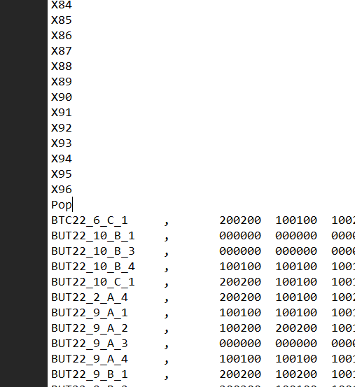 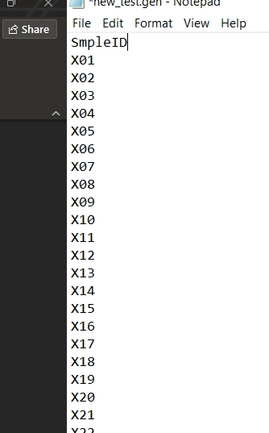

1. The file is now in Genepop format and ready to use. Run lines 42 through 57 to do a quick PCA to just see if the format is usable.
2. Population delineations are baked into Genepop and need to be written in manually according to the genepop format. This code does not address that.